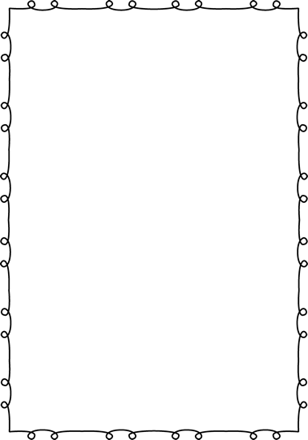

**Kindergarten Supply List**

Welcome to Kindergarten at Verdi Elementary!

The following supplies will be helpful and appreciated:

* 12 pencils (Ticonderoga brand recommended)
* 1 pencil box
* 1 pair of child size scissors (Fiskars brand recommended)
* 2 boxes Crayola Crayons (24 count)
* Black Dry Erase Markers (Expo brand recommended)
* 1 (70 page) spiral notebook
* 1 two-pocket folder (The sturdier, the better.)
* 1 3-prong folder
* 10-15 gluesticks (We go through a lot of these in Kindergarten!)
* Backpack (No wheels, please.)
* 1 box of Ziplock Baggies (Last names starting with A-M, please bring gallon size, and last names starting with N-Z, please bring sandwich size.)
* 1 box of Kleenex
* $25 Class Project Fee- Checks can be made out to Verdi Elementary School. Monies collected will go into a classroom account and will pay for special project supplies, science experiments, photo developing, classroom incentives and Scholastic News Magazine.

Please try to bring all supplies to your child’s Kindergarten Screening appointment. If your family has trouble providing any of the above items, please let me know and we will be happy to help!

Thanks so much!

Ms. Mckemy and Mrs. Peterson